

SIMATS ENGINEERING

Saveetha Institute of Medical and Technical Sciences
Chennai- 602105

Student Name: M.HEMANTH KUMAR Reg. No.: 192525107
Course Code: CSA-1274 Slot: D
Course Name: COMPUITER ARCHITECTURE FOR AGENTIC ARCH
Course Faculty: Dr. SENTHILVADIVU SUBRAMANIAN & Dr. KARTHIK KUMARAGURUBARAN
Project Title: DESIGN AND EXECUTION OF BOOTH’S ALGORITHM USING DIGITAL LOGIC SIMULATION
Module Photographs:
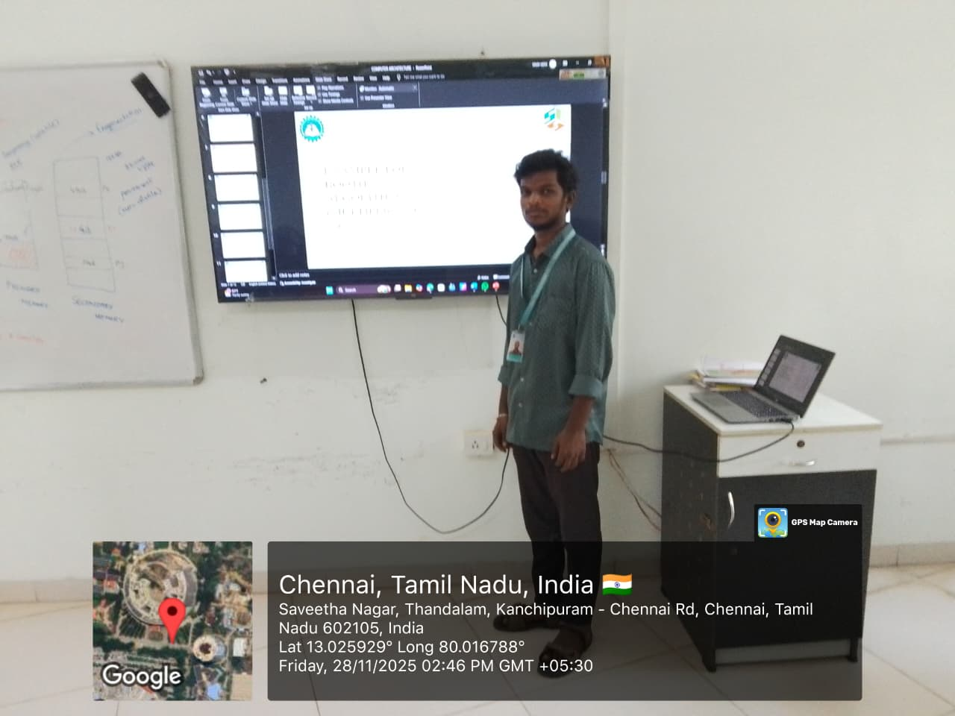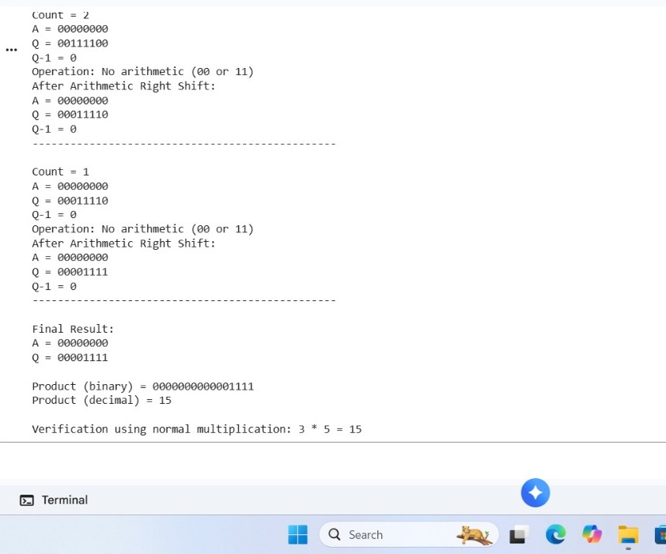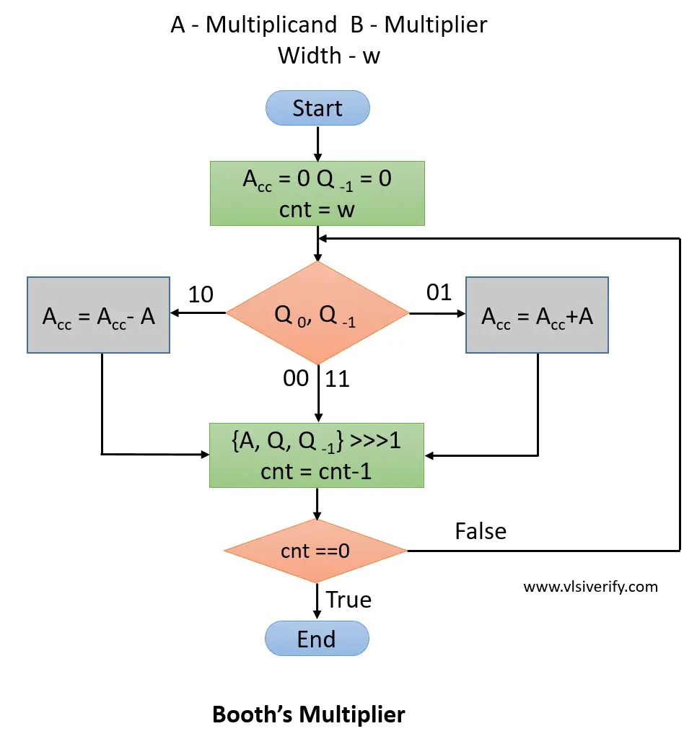

Project Description:
Output and Result Module

Booth’s Algorithm was designed and simulated using digital logic to perform efficient signed binary multiplication. The project used registers, add/subtract units, and an arithmetic right shifter to implement the algorithm’s bit-pair decision process. During simulation, the multiplicand and multiplier were loaded into their respective registers, and operations were executed based on the combination of the multiplier’s least significant bit and the Q-1 bit. The circuit correctly performed addition, subtraction, and shifting across each clock cycle. The final output appeared in the combined A and Q registers, representing the signed product in 2’s complement form. Test simulations, such as multiplying +6 and –5, produced correct results like 11000110 (–30). The design proved Booth’s Algorithm reduces unnecessary operations and improves multiplication efficiency. Overall, the simulation confirmed accurate hardware behavior and validated the practicality of Booth’s Algorithm for digital arithmetic units.

Student Signature Guide Signature

